**ER Modelling Exercise - SMCSE**

The School of Mathematics, Computer Science and Engineering is composed of several departments. Each department is identified by a code, has a departmental office (office number) and a departmental administrator (administrator name). Each department has teaching staffs that teach modules. Each teaching staff member has a staff number, a name, and a salary. Teaching staff are either Academics or Teaching

Assistants. Academics have grades, while Teaching Assistants have contracts

(Contract Number). Most Academics are responsible for one or more modules

(module number, module name, topic), and a module is the responsibility of only one Academic. Teaching Assistants must assist with teaching one or more modules.

Module can have several Teaching Assistants. In each department, one of the Academics acts as the Head of Department, and they have a special responsibility allowance.

Design an E-R diagram for the above database.

Derive a corresponding relational scheme from your E-R diagram.

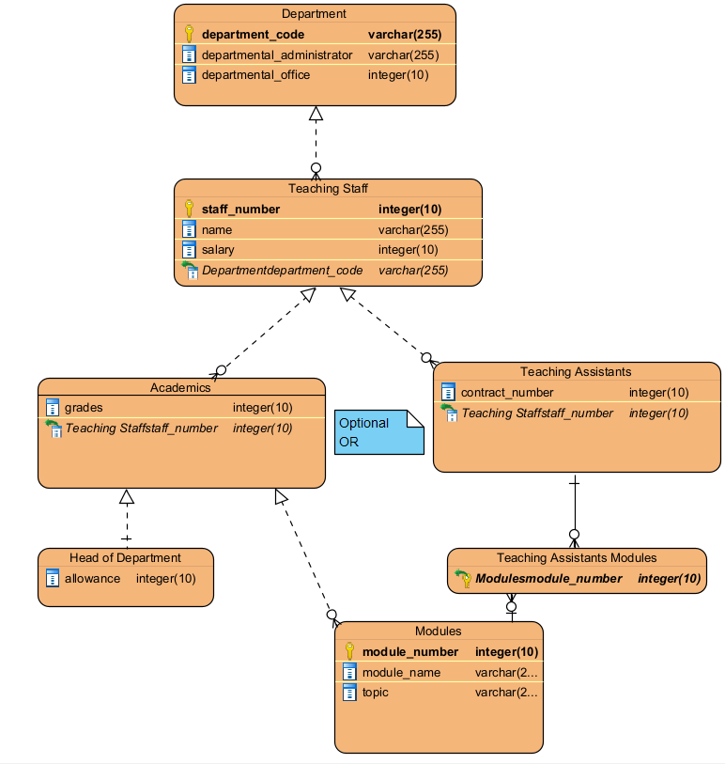

Department (**department_code**, departmental_administrator, departmental_office)

Teaching Staff (**staff_number**, name, salary)

FOREIGN KEY department_code REFERENCE Department (department_code)

Academics (grades)

FOREIGN KEY staff_number REFERENCE Teaching Staff (staff_number)

Head of Department (allowance)

Teaching Assistants (contract_number)

FOREIGN KEY staff_number REFERENCE Teaching Staff (staff_number)

Modules (**module_number**, module_name, topic)

Teaching Assistants Modules ()

FOREIGN KEY module_number REFERENCE Modules (module_number)